CE / CS / SE 3354 · SOFTWARE ENGINEERING · FALL 2026
Project Deliverable P1
Proposal and Requirements — Team Template
Weight 4% · Due Sunday 18 October 2026, 11:59 PM Central · Submit one PDF per team on Canvas
Field | Your entry
Project title | Comet Assist
Team number and section | Team 8, Section 010
Team members (name · net ID) | Michael Maranville mrm230009, Yousif Al Khafaji - dal147540, Himesh Anumala dal813094
Repository URL | https://github.com/michmara13/CometAssist
Document version | 0.4
Date | 10/18/2026

▸ How to use this template
This template is the structure we expect, not a form to pad out. It follows the section ordering of ISO/IEC/IEEE 29148, the current international standard for requirements engineering, so that the document you start now grows into a full requirements specification by P2 rather than being thrown away and rewritten.
Delete every blue box like this one before you submit. They are instructions, not content, and a document that still contains them has not been read by its own authors.
Length: aim for 10 to 14 pages of your own content. A longer document is not a better one. Every section below carries a budget; a section that runs to twice its budget is usually padded, and padding is visible.

▸ What P1 does NOT ask for
P1 is a baseline, not a finished specification. At this milestone we are NOT asking for:
— a software architecture or any design decision (that is P2, after Chapter 8)
— class diagrams, sequence diagrams or state models (that is P2, after Chapters 7 and 9)
— a test plan (that is P3, after Chapter 11)
— any code, screens or a working prototype (P1 is marked on reasoning, not on implementation)
A team that submits an architecture diagram at P1 has spent its effort in the wrong place and will not be credited for it.

0 Revision History and Contribution Record
Both tables below are graded. The contribution record carries the individual 20% of this milestone and must be consistent with your repository history.
Version | Date | Author | Summary of change
0.1 | 10/12/2026 | Michael Maranville | Initial baseline for P1, wrote 1.1 and 1.2
0.2 | 10/14/2026 | Michael Maranville | Wrote 1.3 and all section 2.
0.3 | 10/17/2026 | Yousif Al Khafaji | Sections 3.1 to 3.5
0.4 | 10/18/2026 | Himesh Anumala | Section 5

0.1 Individual contribution record
Team member | What this person produced for P1 | Evidence in the repository
Michael Maranville | Wrote sections 1 and 2. | Created repo and first commit.
Yousif Al Khafaji | Wrote sections 3.1 to 3.5 | CS3354_F2026_P1_Version0_3.docx, Sections 3.1 to 3.5
Himesh Anumala | Wrote Section 5 | Version 4 docx, Section 5, Commit

▸ WHAT GOES HERE
Evidence means something a reader can open: a commit range, an issue number, a pull-request review, a document section you wrote. “Helped with requirements” is not evidence.
Every member must appear with a distinguishable contribution. A row that duplicates another row word for word earns neither member credit.
If a member did not contribute, say so here rather than at the end of term. Section 'Teamwork, Accountability, and Academic Honesty' in the syllabus explains why late complaints cannot be evaluated fairly.

1 Introduction
1.1 Purpose of this document and of the system
▸ WHAT GOES HERE
Two short paragraphs. The first says what this document is and who it is for. The second says what the system is for — the problem, and whose problem it is.
Budget: half a page.
Worked example: “CometLocker addresses the loss of parcels left at the campus post office counter, which currently requires a staffed desk during business hours and leaves students without a way to collect a delivery outside those hours.”

This document is the P1 proposal and requirements baseline for CometAssist, a student support ticketing system. It is written for the course instructors, the project team, and the students and support staff whose needs it records, and it will be expanded into a full specification for P2.

Students with technical or general questions often don’t know which office handles their issue, so requests are misrouted, delayed, or lost, and students can’t see where they stand. CometAssist routes each request to the right team by category, escalates requests that go unhandled, and lets students track progress until resolution.

1.2 Scope
▸ WHAT GOES HERE
A scope statement is only useful if it says what is excluded. Fill both columns. An empty right-hand column means you have not scoped anything.
Budget: the table, plus two sentences on why the exclusions were excluded.

In scope — we will build this | Out of scope — we will not, and why
Ticket submission with a preset category drop-down | Live chat or phone support, which needs staffing that we can't simulate.
Automatic routing of tickets to the team assigned to each category | Our own login system, since we will rely on campus SSO.
Escalation of tickets left unhandled past a set time | AI-generated answers, which are too unreliable to verify.
Ticket status tracking for students and a queue view for staff | Integration with real campus IT systems, which we don't have access to.

Why the exclusions were excluded: Each would add significant effort or depend on access and resources the team doesn’t have this semester. Leaving them out keeps the work on routing and escalation, which is the core of the project.

1.3 Definitions, acronyms and abbreviations
▸ WHAT GOES HERE
Every term your stakeholders use in a way a newcomer would misread, and every abbreviation, expanded at first use. If a word in your domain has two meanings, that is a finding — record both meanings here and resolve it in section 5.

Term or abbreviation | Meaning as used in this project
Ticket | A single support request submitted by a student
Escalation | Moving a ticket to a higher priority and support tier when it needs to be handled quicker.
Category | A preset topic a student selects when submitting a ticket, which determines where it is routed

1.4 References
▸ WHAT GOES HERE
Anything you relied on: a standard, a campus policy, an existing system's documentation, an interview transcript in your repository. Give each a number so requirements in section 3 can cite it as a source.

[R1]

2 Overall Description
2.1 Product perspective and context
▸ WHAT GOES HERE
Draw the context diagram: one box for your system, every external actor and external system around it, and a labelled line for each interface. Paste the image here.
This is the diagram that decides what you are responsible for. Anything inside the box is your work. Anything you call on and do not build is an external system — and it still goes on the diagram.
Budget: one diagram and one paragraph explaining the boundary choice.

Paste the context diagram here, then explain in one paragraph why the boundary sits where it does.
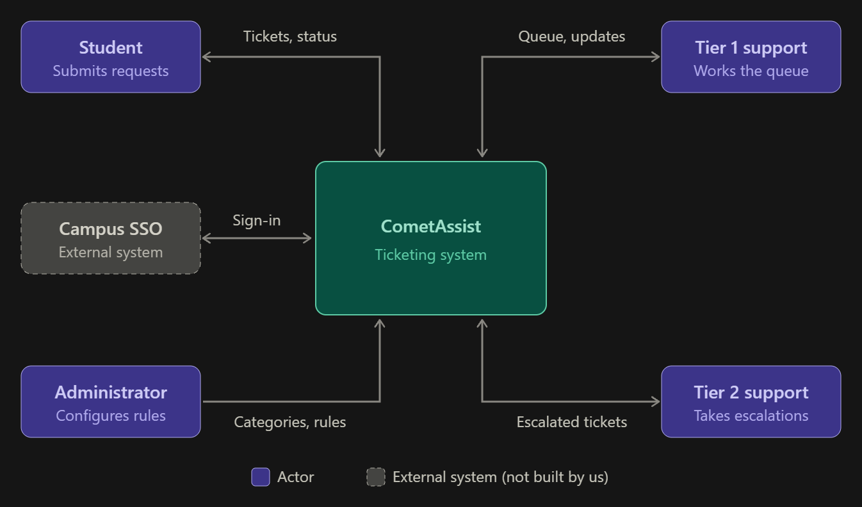
CometAssist is a standalone system covering ticket submission, category-based routing, escalation, and status tracking. Login is handled by the existing campus SSO, which sits outside the boundary because we use it but do not build it. This keeps the team’s work focused on routing and escalation.

2.2 Stakeholders and how you reached them
▸ WHAT GOES HERE
Everyone whose needs shape the system, including the ones who will never use it — whoever pays, whoever operates it, whoever has to comply with something because of it.
The last column is the one that earns marks. “We assumed” is an honest and acceptable answer at P1; “interviewed on 9 Oct, notes in /docs/elicitation” is a better one. An entry with no basis at all is not.

Stakeholder | Role in relation to the system | What they need from it | How you learned this
Students | Primary users who submit and track tickets | A simple way to get help without knowing which office to contact. | We are all students that have to go explore the UTD websites forever just to find who to contact.
Campus IT | Would operate and maintain the system | Low maintained effort plus SSO login compatibility. | Assumed
Admins | Maintains categories and escalation rules | A way to change categories and time limits without code changes | Assumed
Support | Handle incoming tickets in their queue | Tickets that arrive in the right queue with enough detail to act on it | Assumed

2.3 User characteristics
▸ WHAT GOES HERE
Who the users are, what they already know, what they cannot be assumed to know, and anything about them that constrains the system — accessibility needs, the device they will be holding, the hurry they are in.
Budget: a short paragraph per user class.

Type here.
Students. They are comfortable with web apps and SSO but can't be assumed to know how IT support is organized or which office handles what. Many will submit tickets from a phone, often while already frustrated or in a hurry. So, the form must be quick to complete on a small screen.

Support staff. Staff know the technical subject matter and work at a desktop during shifts. They need to scan and act on many tickets quickly, so the queue view matters more to them than a polished design. They can’t be assumed to have time for training on a new tool.
Administrators. Administrators are experienced IT staff who understand how support is organized. They make changes infrequently, so the configuration screens must be clear without relying on memory of how they worked last time.

2.4 Constraints
▸ WHAT GOES HERE
A constraint removes a design choice. “We must use the existing campus single sign-on service” is a constraint. “The system should be fast” is not — that is a quality requirement, and it belongs in 3.2.
Record the source of each constraint. An unsourced constraint is usually a preference somebody has mistaken for a rule.

Type here.
The system must use the existing campus for single sign-on service for login. The team must use free or student-licensed tools and hosting.

2.5 Assumptions and dependencies
▸ WHAT GOES HERE
An assumption is something you are treating as true without having confirmed it. A dependency is something outside your control that your plan needs.
State what breaks if each one turns out to be wrong. That sentence is the whole value of this section.

# | Assumption or dependency | What breaks if it does not hold
A1 | Campus SSO can be used by a student project, or simulated well enough for development. | Login must be built in-house, adding work and contradicting the 1.2 scope.
A2 | Support requests fall into a small, stable set of categories that students can choose between. | Routing by category fails if students can’t pick the right one, and tickets get misrouted anyway.
A3 | Support staff will check the CometAssist queue regularly without email alerts. | Tickets sit unnoticed, and escalation becomes the main way anything gets handled.

2.6 Feasibility summary
▸ WHAT GOES HERE
Four short verdicts, each with the evidence behind it. This is the Chapter 4 material, applied to your own project.
A verdict with no evidence is an opinion. “Technically feasible — two team members have used this framework before, see repository /spike-01” is evidence. “We think we can do it” is not.

Feasibility gate | Verdict | Evidence behind the verdict
Technical | Feasible | Ticket submission, routing, and status tracking are standard web app features.
Operational | Feasible with Risk | Students already use web forms for campus services.
Schedule | Feasible if scope holds | The 1.2 exclusions keep the work to four core features.
Economic / resource | Feasible | Free or student-licensed tools and hosting cover the build.

3 Specific Requirements
▸ WHAT GOES HERE
This section carries the most marks in P1. Everything else sets it up.
Expected volume: 8 to 15 functional requirements, 4 to 6 quality requirements, 2 to 4 constraint requirements, 4 to 6 use cases with 2 written out in full. More is not better; vague is worse than few.
Every requirement must pass the testability test from Chapter 5: a reader must be able to decide pass or fail without arguing. That needs a measurable condition and a stated way of checking it.
Write every requirement as a single “shall” sentence. If you need the word “and” twice, you have two requirements.

3.1 Functional requirements
▸ WHAT GOES HERE
What the system does. Use the identifier FR-nn and keep the identifiers stable from now on — P2 and P3 will refer back to them.
Priority uses MoSCoW: MUST (the release fails without it), SHOULD (important, there is a workaround), COULD (desirable), WON'T (agreed out of this release).
Source is the stakeholder or reference the requirement came from — a row from 2.2, or a reference from 1.4.

Tickets will have three possible statuses. Open, In Progress, and Resolved. Open means the ticket hasn’t been worked on yet. Resolved is the final status. The active queue has Open or In Progress tickets. New tickets have Normal priority. Escalation raises the priority to High and moves the ticket from Tier 1 to Tier 2 while keeping the Open status.
A ticket can be escalated when it is still Open with Normal Priority in Tier 1 and its age reaches the time limit set. Age is measured in hours from submission. The initial limit is 24 hours, and each ticket should escalate only once.
Students may only read the tickets they have submitted. Support staff may read and update the tickets only assigned to their team. Only administrators may change categories or escalation settings. Users who aren’t signed in shouldn’t have access to tickets or configuration settings.
ID | Requirement — one “shall” sentence | Priority | Source | Acceptance criterion
FR-01 | The system shall let a signed in student submit a ticket with a title, description and a category from a drop down list. | MUST | Students Section 2.2 | Blank required fields prevent the submission. Submit two completely filled out tickets, and each should get a different ticket ID with Open status and Normal priority.
FR-02 | The system shall send each new ticket to the Tier 1 support team that is listed for its category. | MUST | Students and Support  Section 2.2 | Submit tickets under different categories. Each ticket appears in the queue listed for its category.
FR-03 | The system shall let students view the details and current status of their own ticket. | MUST | Students  Section 2.2 | A student can see their submitted information, status, priority, and assigned team. Their tickets remain after signing out and signing back in. Another student’s tickets are hidden.
FR-04 | The system shall let support staff view active tickets assigned to their team. | MUST | Support  Section 2.2 | Staff see only their team’s Open or In Progress tickets. High priority tickets appear first, then the oldest within each priority. Opening a ticket shows its description and current status.
FR-05 | The system shall let support staff change a ticket from Open to In Progress or from In Progress to Resolved. | MUST | Students and Support  Section 2.2 | Assigned staff make both changes. The student sees the saved status after refreshing or signing back in. Resolved tickets cannot be reopened.
FR-06 | The system shall automatically send an unhandled ticket to Tier 2 support with High priority once it reaches the set time limit. | MUST | Support  Sections 1.2 and 2.2 | Set the time limit to one hour. An Open Tier 1 ticket that reaches the one hour mark moves to Tier 2 at High Priority within five minutes. In Progress, Resolved and already escalated tickets do not move.
FR-07 | The system shall let an administrator add or edit a ticket category and the support team for that category. | MUST | Admins  Section 2.2 | Save a category name with a Tier 1 team. Reopen settings to confirm the change. New tickets follow the saved choice. A blank name or missing team prevents saving.
FR-08 | The system shall let an administrator change the time limit and Tier 2 team used for escalation. | MUST | Admins  Section 2.2 | Save a positive whole number of hours with a Tier 2 team. Sign out and back in to confirm the values. Zero, negative, fraction or missing hours and a missing team prevents the settings from being saved.

3.2 Quality requirements
▸ WHAT GOES HERE
A quality requirement says how well, not what. Performance, availability, usability, accessibility, security, maintainability.
Three ingredients, every time: a number, the condition it holds under, and how it will be measured. “The system shall be responsive” has none of the three and earns nothing.
Worked example: “QR-01 Ninety-five percent of searches shall return results within 2 seconds, measured over one working week under normal load of up to 50 concurrent users.”

ID | Requirement — with threshold, condition and method | Priority | Source | How it will be verified
QR-01 | The system shall finish a ticket submission or display a ticket list within ten seconds on the test computer with one signed in user and up to 25 stored tickets. | SHOULD | Students and Support  Section 2.3 | Time 25 actions covering ticket submission, the student ticket list and the staff queue. Each result appears within ten seconds of the action.
QR-02 | The system shall keep 100% of saved tickets and settings after a normal application restart with up to 25 stored tickets. | MUST | Students, Support, and Admins  Section 2.3 | Save 25 tickets with different statuses. Save a settings change. Close and restart the application. All saved details, statuses and settings match the values before the restart.
QR-03 | The system shall show all three ticket fields and the Submit button without sideways scrolling at widths of 360 and 1280 pixels. | SHOULD | Students  Section 2.3 | Check the ticket form at both widths. The title, description, category, and Submit button are fully visible by scrolling vertically, with no cut offs.
QR-04 | The system shall block 100% of requests that break the access rules in section 3.1 | MUST | Students, Support, and Admins  Section 2.2 | Check four cases.  - A signed out user opens a ticket  - A student opens another students ticket  - A student changes admin settings  - Staff from another team change a ticket  Each request is denied without showing protected data or saving a change.

3.3 Constraint requirements
▸ WHAT GOES HERE
Constraints carried forward from 2.4, written in requirement form with an identifier so they can be traced like any other requirement.

ID | Constraint — one sentence | Source | Why it cannot be negotiated
CON-01 | The system shall use the campus SSO for signing in, with a clearly labeled simulation used. | Section 2.4 and 2.5 | The scope excludes creating a separate password system.
CON-02 | The system shall use only tools that are free to the team. | Section 2.4 | The project plan relies on free resources.

3.4 Initial use cases
▸ WHAT GOES HERE
First the diagram: actors, use cases, the system boundary, and any «include» or «extend» relationships. Paste the image.
Then write out two use cases in full — choose the two that are hardest to scope, not the two that are easiest to write. Use the template below for each.
Reminder from Chapter 6: a use case is started by an actor, ends when that actor has finished something they came to do, and has value on its own. “Validate Password” is a step, not a use case.

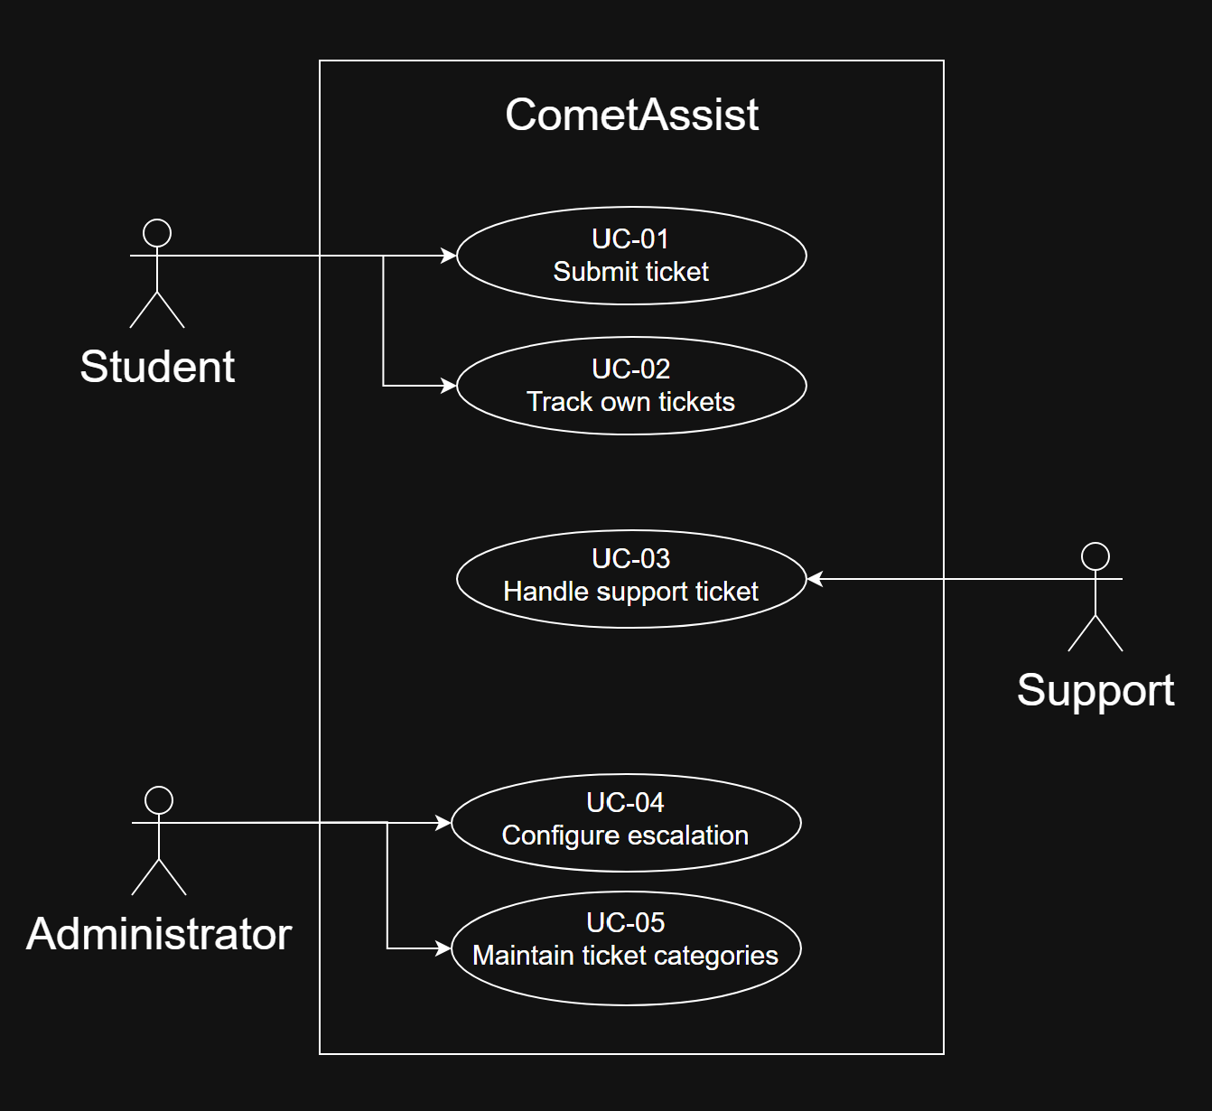

Expanded UC-03
Field | Content
Identifier and name | UC-03 Handle support ticket
Primary actor | Support staff from the assigned Tier 1 or Tier 2 team.
Supporting actors | None. Escalation is automatic system behavior supporting this goal.
Preconditions — what must be true before it starts | The staff member is signed in and belongs to a configured support team. Tickets may already exist in that team’s queue.
Trigger — what starts it | The staff member opens their team’s ticket queue.
Main success scenario — numbered steps | - The staff member opens the assigned team queue  - The system lists that team’s Open and In Progress tickets, showing High Priority first and then oldest submission first within each priority.  - The staff member selects an Open ticket.  - The system displays the ticket details and current state.  - The staff member marks the ticket In Progress when work begins.  - The system saves the new status and makes it visible to the student.  - After addressing the issue, the staff member marks the ticket Resolved.  - The system saves the resolution status for later viewing.
Alternative and exception flows | 2a. Empty queue - the system shows that no tickets are assigned, the use case ends.  3a. Already In Progress – the assigned staff member open that ticket and continues from step 7 after completing the work.  3b. Ticket moved to another team before it is opened, the access is then denied and the queue is refreshed.  6a or 8a. A save fails – the previous saved status stays and the staff member can try again.
Postconditions — what is true when it succeeds | The ticket is saved as Resolved and the submitting student can see its final state. The ticket stays stored for viewing later.
Requirements realised | FR-04, FR-05, FR-06, FR-09, and FR-12.  QR-01, QR-02, and QR-04.

Expanded UC-04
Field | Content
Identifier and name | UC-04 Configure escalation
Primary actor | Administrator
Supporting actors | None.
Preconditions — what must be true before it starts | The administrator is signed in with the admin role. At least one Tier 2 support team is available for selection.
Trigger — what starts it | The administrator opens the escalation settings.
Main success scenario — numbered steps | - The system displays the current escalation time and Tier 2 destination.  - The administrator enters a positive whole number of hours.  - The administrator selects an available Tier 2 support team.  - The administrator selects Save.  - The system validates both values and stores the rule.  - The system confirms the change and displays the saved values.  - The saved rule applies to existing eligible Tier 1 tickets and new tickets.
Alternative and exception flows | 2a. Hours are missing, zero, negative, or a fraction. The saving is rejected. The system goes back to the previously saved rule.  3a. No available Tier 2 team is selected. The saving is rejected until a valid team is chosen.  4a. The administrator exits without saving. The existing rule stays applied.  5a. A save fails. The previous saved rule stays applied and the administrator can try again.
Postconditions — what is true when it succeeds | The rule is stored and remains available in future sessions. Open Tier 1 tickets already older than the new time limit escalate within five minutes of the change. Tickets already assigned to Tier 2 keep their assignment.
Requirements realised | FR-06 and FR-08  QR-02 and QR-04

3.5 Requirements to use case traceability
▸ WHAT GOES HERE
One row per requirement. The matrix is doing its job when it shows you something you did not already know.
Two shapes of trouble, and you must say what you did about each: a requirement that reaches no use case (either a use case is missing, or the requirement is not functional and belongs in 3.2), and a use case nothing traces to (either it is out of scope, or a requirement was never written down).

Requirement ID | Use case(s) that realise it | If blank — why, and what you will do
FR-01 | UC-01
FR-02 | UC-01
FR-03 | UC-02
FR-04 | UC-03
FR-05 | UC-03
FR-06 | UC-03, UC-04
FR-07 | UC-05
FR-08 | UC-04
QR-01 | UC-01, UC-02, UC-03
QR-02 | UC-01 to UC-05
QR-03 | UC-01
QR-04 | UC-01 to UC-05
CON-01 | UC-01 to UC-05
CON-02 | n/a | Resource constraint, checked by reviewing tools.

What the matrix revealed, and what you changed because of it: CON-02 is marked n/a because it limits the project cost instead of describing something a user does.

4 Project Plan
4.1 Team roles and working agreement
Team member | Role for P1 to P2 | How the team makes a decision when it disagrees

4.2 Plan to P2
▸ WHAT GOES HERE
Milestones between now and 8 November, each with a date and a named owner. Five to eight rows is right.

Date | What will be finished | Owner

4.3 Risks
▸ WHAT GOES HERE
Your five biggest. A risk is something that has not happened yet — if it has already happened it is a problem, and it belongs in section 5.
Mitigation must be an action with an owner, not an intention. “Start early” is not a mitigation.

# | Risk | Likelihood | Impact | Mitigation — action and owner
R1
R2
R3
R4
R5

4.4 Repository and tooling
▸ WHAT GOES HERE
The repository URL, the branch and commit conventions you have agreed, how issues are used, and who has access. The instructor must be able to open it.

Type here.

4.5 Declaration of AI tool use
▸ WHAT GOES HERE
List every artificial intelligence tool the team used for P1, what it was used for, and what you did to check its output.
Using these tools is permitted. Not declaring them is not. Start the log now — the full AI-use log is required evidence at P3, and reconstructing it in December is much harder than keeping it from October.

Tool | What it was used for | Who used it | How the output was checked
Claude AI | Refining questions/helping find out who can help answer questions. | Himesh | I read through the output and checked if the “Who can answer it” section answers existed/mades sense.

5 Open Questions
▸ WHAT GOES HERE
A question you cannot answer from what you have is a finding, not a failure. It belongs here, in writing, with the name of the person who can answer it and the date you need the answer by.
This section is graded, and an empty one is a warning sign. Every real project at this stage has open questions. A team reporting none has either not looked hard enough or has quietly invented answers — and an invented answer is a business decision the team had no authority to make.
Carry each open question forward into P2 with its resolution, or with a note that it is still open.

# | The question | Who can answer it | Needed by | What you assumed in the meantime
Q1 | Does escalation mean higher priority, moving to a senior tier, or both? | UTD OIT Help Desk | 25 Oct | Both, within the same team.
Q2 | How long can a ticket sit before it escalates? | UTD OIT Help Desk | 25 Oct | One business day with no staff response.
Q3 | What categories should students choose from, and which team owns each? | UTD OIT Help Desk | 1 Nov | Account and Login, Wifi and Network, Software, eLearning/Canvas, Registration, Other.
Q4 | Can we use campus SSO, or a test version of it? | UTD OIT Help Desk | 25 Oct | We use DUO login.
Q5 | Do staff or students need email alerts? | Support staff and students | 1 Nov | Yes, updates show in the app and email reminders.

6 Baseline Declaration
▸ WHAT GOES HERE
Once you submit, the content of this document is your P1 baseline. From this point, changes to requirements are made through change control, not by quiet editing — this is the Chapter 5 practice, applied to your own project.
At P2 you will submit this same document, grown and revised, with the revision history in section 0 showing what changed and why. Do not start a new file.

We confirm that the requirements in section 3 represent our agreed baseline as of the submission date, and that every team member has read this document in full.
Team member | Signature or typed name | Date
Himesh Anumala | Himesh Anumala | 10/18/2026

How P1 Is Marked
P1 is worth 4% of the course grade. Following the syllabus, 80 points are for the shared team artifact and 20 for individual contribution evidence.
Criterion | Points | What full marks look like
Problem, scope and context (1.1, 1.2, 2.1) | 10 | The problem is a problem somebody actually has. The out-of-scope column is filled and the exclusions are justified. The context diagram's boundary matches what sections 2 and 3 claim.
Stakeholders and elicitation (2.2, 2.3) | 10 | Stakeholders include at least one who will never use the system. Every need has a stated basis, and assumptions are labelled as assumptions rather than disguised as findings.
Requirements quality (3.1, 3.2, 3.3) | 25 | Every requirement is one testable “shall” sentence with an identifier, a priority, a source and an acceptance criterion. Quality requirements carry a threshold, a condition and a method. Constraints are distinguished from quality requirements.
Use cases and traceability (3.4, 3.5) | 20 | Use cases are at actor-goal level, not steps. Two are written out in full, including alternative flows. The matrix is complete and the team says what the gaps mean and what they did about them.
Feasibility and plan (2.6, 4) | 10 | Each feasibility verdict is backed by evidence a reader can check. The plan has dates and owners. Risks are future events with actionable mitigations.
Open questions and baseline (5, 6) | 5 | Real open questions, with an owner and a date, and an honest statement of what was assumed in the meantime.
Document quality | — | Guidance boxes removed, sections in order, within the length budget, readable. Marks are deducted here, not awarded.
Individual contribution evidence (0.1) | 20 | Every member's contribution is distinguishable and traceable to something in the repository a reader can open.

▸ Where marks are lost
Three things that cost teams the most marks every year:
1. Requirements that cannot be tested. “The system shall be user-friendly” earns nothing, however good the rest of the document is. Section 3 is 25 of the 80 team points and this is where they are lost.
2. Use cases written at step level. “Log In”, “Validate Card” and “Open Gate” are three steps of one use case. A diagram of fifteen tiny ovals scores lower than one with five real ones.
3. An empty section 5. It reads as a team that resolved its ambiguities by guessing.

